MAJOR PROJECT REPORT
ICT-452

Submitted in partial fulfillment of the requirements for the award of the degree of

Bachelor of Technology
in

computer science and engineering

AI-ExamGaurd

(Computer Based Test(CBT) Platform embedded with AI proctoring(AI ExamGuard))



GURU GOBIND SINGH INDRAPRASTHSA UNIVERSITY

SUBMITTED TO: SUBMITTED BY:
Prof. R. Goyal Mohd Fardeen Alam
USICT(GGSIPU) 01416403222
B. Tech-CSE (8th Sem)

Table of Contents

S. No. | Content | Page No.
1 | Declaration
2 | Acknowledgement
3 | Introduction
4 | Project Overview
5 | Tools and Technology Used
6 | Implementation & Images
7 | References

DECLARATION

I, Mohd Fardeen Alam (Enrollment No. 01416403222), a student of B.Tech (CSE 8th Semester), USICT, Guru Gobind Singh Indraprastha University, hereby declare that the work which is presented in this Major Project Report entitled "AI-ExamGuard" is an original and authentic work of mine under the technical guidance of Prof.R. Goyal , USIC&T. I declare that the work in this project has not been submitted in full or in any part for any diploma or degree course of this or any other University to the best of my knowledge and belief. I will be solely responsible myself for any copyright infringement or plagiarism, if any, in the said work, and declare that all necessary due acknowledgement has been made in the content of said work. My supervisor/ guide shall not be held responsible for full or partial violation of copyright or intellectual property rights or any type of plagiarism involved above in the said work.

Mohd FArdeen Alam
01416403222

ACKNOWLEDGEMENT

It is a genuine pleasure to express my profound gratitude and deep regards to my guide "Prof. R. Goyal" for his exemplary guidance, monitoring and constant encouragement. I would like to express my special thanks to USICT who gave me the golden opportunity to do this wonderful project on the topic “AI-ExamGuard” (Computer Based Test(CBT) Platform embedded with AI proctoring(AI ExamGuard)) which helped me in doing a lot of learning and I came to understand about so many new things.

INTRODUCTION

About Project
India's rapid urbanization has brought a growing challenge - the effective management of public cleanliness and civic hygiene. Despite government initiatives like the Swachh Bharat Abhiyan, a significant gap persists between the reporting of cleanliness issues and their timely resolution. Citizens lack a streamlined mechanism to report civic problems such as overflowing garbage bins, illegal dumping, or clogged drains, while municipal authorities struggle with inefficient manual complaint handling and poor accountability systems.
SwachhSetu - meaning "Bridge to Cleanliness" - is an AI-powered civic cleanliness reporting and response platform designed to bridge this gap between citizens and municipal bodies. The platform empowers citizens to report sanitation issues by submitting geotagged photographs and descriptions. These reports are then analyzed by an integrated AI engine that automatically classifies the issue, assesses its severity, and routes it to the appropriate municipal department for resolution.
SwachhSetu operates on a three-tier model:
- Citizens can submit complaints with photo and location evidence and track real-time resolution status.
- Municipal Workers receive task assignments, update ground status, and upload proof of resolution.
- Admin Dashboard provides supervisors with heatmaps, analytics, and resolution timelines.
Unlike traditional complaint portals that rely on manual processing, SwachhSetu's AI backbone ensures faster categorization, smarter prioritization, and data-driven decision-making. The system is scalable across cities of varying sizes, making it viable for both metropolitan corporations and smaller municipal bodies - a step toward building smarter, cleaner, and more responsive cities.

Project Overview

Project Title: SwachhSetu - An AI-Powered Civic Cleanliness Reporting and Response Platform

Project Type: Full-Stack Web Application with Spring AI Integration

Domain: Smart City Solutions / Civic Technology / Environmental Management

Tech Stack:
- Frontend: ReactJS (Internal State Management) + Tailwind CSS
- Backend: Java Spring Boot + Spring AI
- Database: MySQL

SwachhSetu is a full-stack web application that allows citizens to report public cleanliness and sanitation issues to their local municipal authorities. What makes SwachhSetu unique is its integration of Spring AI, which processes uploaded complaint images and generates AI-powered responses including step-by-step cleaning instructions and an AI-generated visual of how the area would look after cleaning. This makes the platform not just a complaint portal but an intelligent civic assistance system.
The platform serves three categories of users Citizens, Cleaning Teams, and Administrators each with a dedicated, role-based interface.

System Workflow

The overall workflow of SwachhSetu is as follows:

- User Registration / Login - The citizen lands on a visually rich landing page and registers or logs in to access the platform.

- Home Dashboard - After login, the user is greeted with a clean dashboard showing cleanliness drive articles, community event cards, and a prominent "Raise a Complaint" button.

- Complaint Submission - The user navigates to the complaint form, uploads an image of the affected area, and enters the area details.

- AI Processing - Spring AI analyzes the complaint and generates:
  - Step-by-step instructions on how to clean the reported area
  - An AI-generated image depicting how the area would look post-cleaning

- Team Assignment - The complaint is forwarded to the admin panel, where a cleaning team is assigned to the reported area.

- Admin Management - The administrator manages teams, monitors complaint status, and tracks resolution progress through a dedicated admin panel.

Key Features

- Beautiful Landing Page - Semantic, visually appealing UI with full responsiveness built using ReactJS and Tailwind CSS
- Role-Based Access - Separate interfaces for Citizens, Cleaning Teams, and Admins
- AI-Powered Complaint Response - Spring AI generates cleaning steps and post-clean area visualization upon complaint submission
- Community Engagement - Articles and event cards related to cleanliness drives displayed on the home dashboard
- Team Assignment Workflow -Admin can assign and manage cleaning teams for each reported complaint
- MySQL Database - Structured storage of users, complaints, teams, and resolution data
- RESTful APIs - All backend operations handled via Spring Boot REST APIs.

Module Breakdown

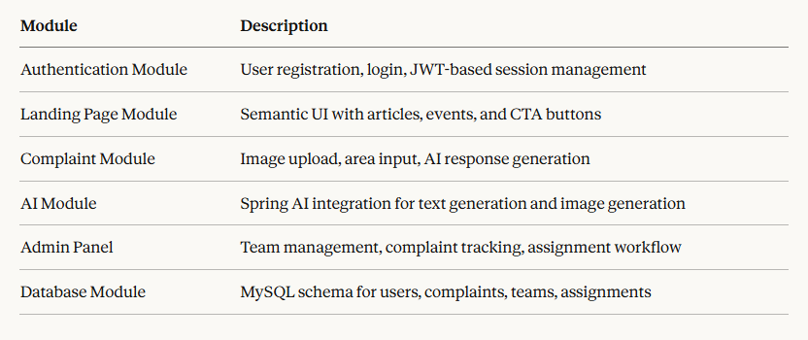

Objectives

- To provide citizens with an intuitive interface for reporting civic cleanliness issues
- To leverage Spring AI for automated generation of cleaning guidance and visual post-clean imagery
- To enable administrators to efficiently manage and assign cleaning teams
- To build a scalable, maintainable full-stack application using industry-standard technologies
- To foster community awareness through cleanliness drive articles and events on the platform

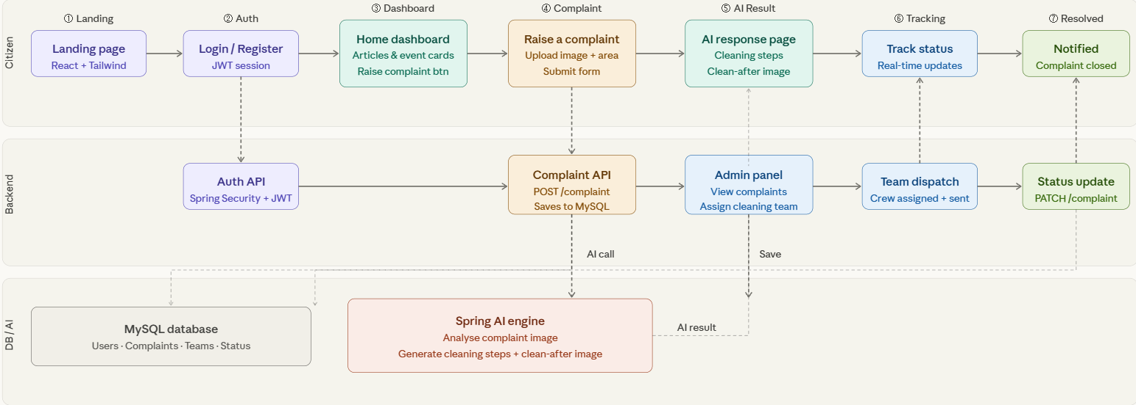

1.1 SwachhSetu workflow diagram

The flow breaks down into 9 clear steps:

- Citizen hits the landing page
- Logs in / Registers (JWT auth)
- Sees the home dashboard with articles & events
- Raises a complaint (image + area)
- Spring AI processes it → returns cleaning steps + clean-after image
- Admin is notified, complaint saved to MySQL
- Admin assigns a cleaning team
- Team resolves the issue, status updated
- Citizen gets notified -w complaint closed.

Tools and Technologies Used

1. ReactJS

What: JavaScript library by Meta for building user interfaces.
Why: Builds SwachhSetu's dynamic pages - dashboard, complaint form, response page - using reusable components with built-in state management.

2. Tailwind CSS

What: Utility-first CSS framework for styling.
Why: Makes the UI visually appealing and responsive quickly without writing custom CSS files.

3. Java Spring Boot

What: Java framework for building REST APIs.
Why: Powers the entire backend - handles complaints, user auth, team assignment, and AI integration in one place.

4. Spring AI

What: Spring module that connects Java apps to AI/LLM providers like OpenAI.
Why: Generates cleaning step instructions and a clean-after image when a complaint is submitted - the core intelligence of SwachhSetu.

5. MySQL

What: Relational database management system.
Why: Stores all structured data - users, complaints, teams, assignments, and statuses - with proper relationships between them.

6. Spring Security + JWT

What: Authentication framework + token-based session management.
Why: Ensures only authorized users access their respective roles - citizen, admin, or field worker - securely.

7. Postman

What: API testing tool.
Why: Tests all backend REST APIs during development before connecting to the frontend.

8. Git & GitHub

What: Version control system + cloud code hosting.
Why: Tracks all code changes and keeps the project organized and backed up throughout development.

PROJECT DESCRIPTION

SwachhSetu

(An AI Powered Civic Cleanliness Reporting and Response Platform)

SwachhSetu is a full-stack, AI-powered civic cleanliness reporting and response platform designed to bridge the gap between citizens and municipal authorities in addressing public sanitation issues. The name "SwachhSetu" translates to "Bridge to Cleanliness" - reflecting its core purpose of connecting people to a cleaner environment through technology.

The platform addresses a very real and widespread problem - citizens often notice dirty public spaces, overflowing garbage, or clogged drains but have no simple, effective way to report them and expect timely action. SwachhSetu solves this by providing an intuitive digital platform where anyone can raise a complaint in seconds, just by uploading a photo and mentioning the area.

What makes SwachhSetu different from a basic complaint portal is its AI intelligence layer. Powered by Spring AI, the platform does not just log the complaint - it actively responds to it. The moment a complaint is submitted, the system analyses the image and area details and generates two outputs - a step-by-step cleaning guide for the area and an AI-generated image showing how the area would look after cleaning. This gives citizens immediate, meaningful feedback and sets a visual expectation for resolution.

The platform is built for three types of users. Citizens register, submit complaints, and track their resolution status in real time. Administrators manage the platform through a dedicated admin panel where they can view all complaints, create and manage cleaning teams, and assign teams to specific complaints. Cleaning teams receive their task assignments and execute ground-level resolution.

On the technical side, SwachhSetu uses ReactJS with Tailwind CSS for a modern, responsive, and visually rich frontend. The backend is built entirely on Java Spring Boot, handling all REST APIs, business logic, and AI integration through Spring AI. All data is stored and managed in a MySQL relational database, with Spring Security and JWT ensuring secure, role-based access across all user types.

IMPLEMENTATION

The SwachhSetu Civic Cleanliness Reporting Application was implemented using a modern full-stack approach, combining React.js for the frontend and Spring Boot for the backend. The application follows a layered architecture while maintaining a clear MVC (Model-View-Controller) design pattern, ensuring modularity, scalability, and maintainability.

Frontend Implementation
- The user interface was built using React.js with Tailwind CSS for responsive and visually appealing design.
- Citizens can register, login, raise cleanliness complaints by uploading an image with area details, and view AI-generated cleaning steps and clean-after image seamlessly.
- Form validations were implemented to ensure correct input of user information and complaint details.
- The frontend communicates with backend services via RESTful APIs using Axios, ensuring smooth data exchange.

Backend Implementation

The backend is developed in Spring Boot, following a layered architecture:
- Controller Layer: Handles incoming HTTP requests and returns appropriate responses.

- Service Layer: Implements business logic for complaint processing, Spring AI response generation, and team assignment.

- Repository Layer: Manages all database operations using JPA/Hibernate.

MySQL is used as the database for storing user, complaint, and team information. The database swachhsetu_db is managed seamlessly using MySQL Workbench.

Security is implemented using JWT authentication to protect user data and complaint operations with role-based access for Citizens and Admins.

Spring AI Integration

- Spring AI is integrated directly into the Spring Boot backend using the OpenAI provider.

- When a citizen submits a complaint, Spring AI processes the area details and generates step-by-step cleaning instructions using the Chat Model.

- Spring AI also generates an AI image of how the cleaned area would look using the Image Model (DALL·E).

- This eliminates the need for any separate Python or ML microservice.

Key Features Implemented

- User authentication and authorization

- Beautiful landing page with cleanliness drive articles and event cards

- Complaint submission with image upload and area description

- AI-generated cleaning steps and clean-after image on response page

- Admin panel for team management and complaint assignment

Challenges Faced

- Integrating Spring AI with the complaint workflow for real-time AI response generation

- Handling image upload from React frontend to Spring Boot backend using MultipartFile

- Implementing role-based JWT authentication for Citizens and Admins

- Connecting frontend and backend with proper API handling using Axios interceptors

Images of the Interface

Landing Page of the website

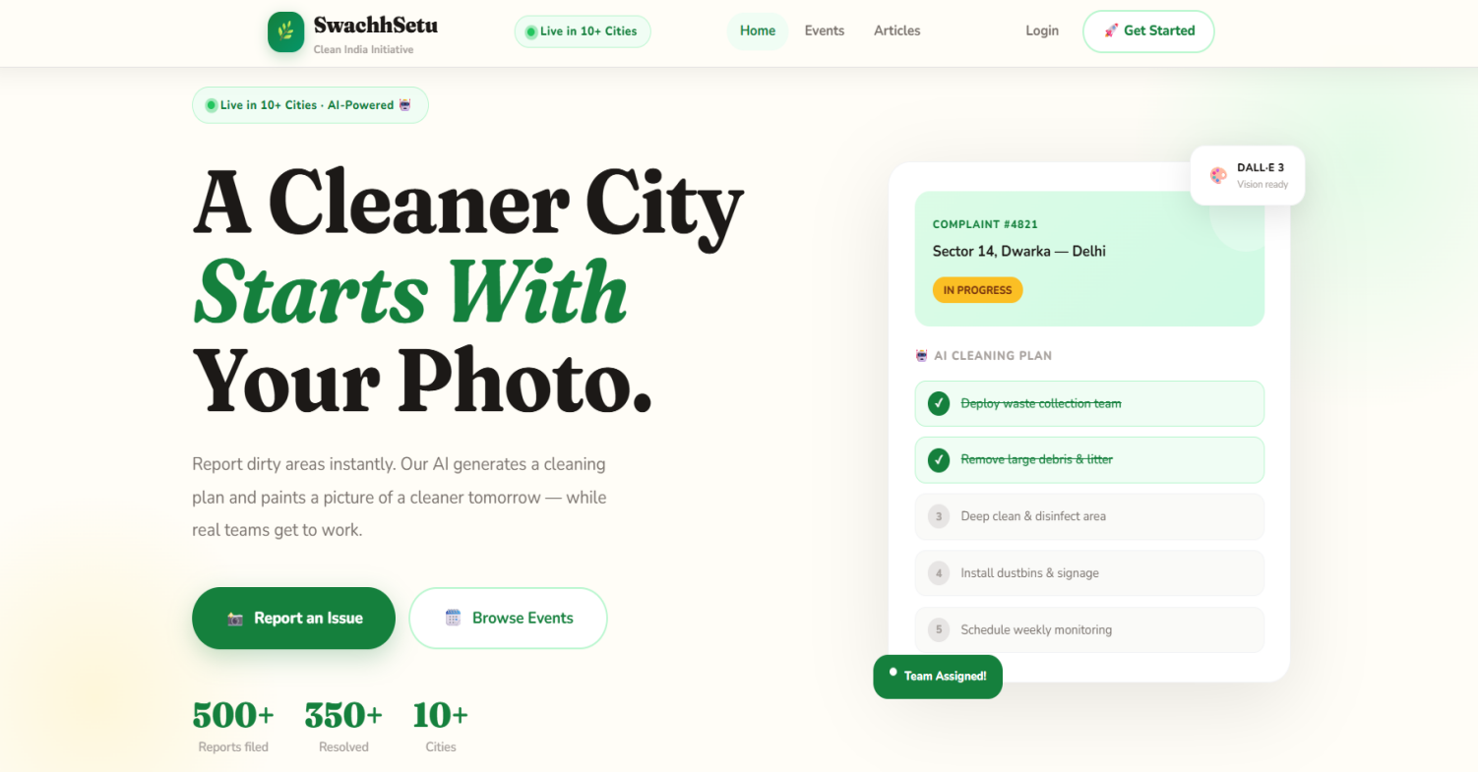

1.2 Landing Page of the website

Login/Register page.

We can use Account nav to open the login/register page.

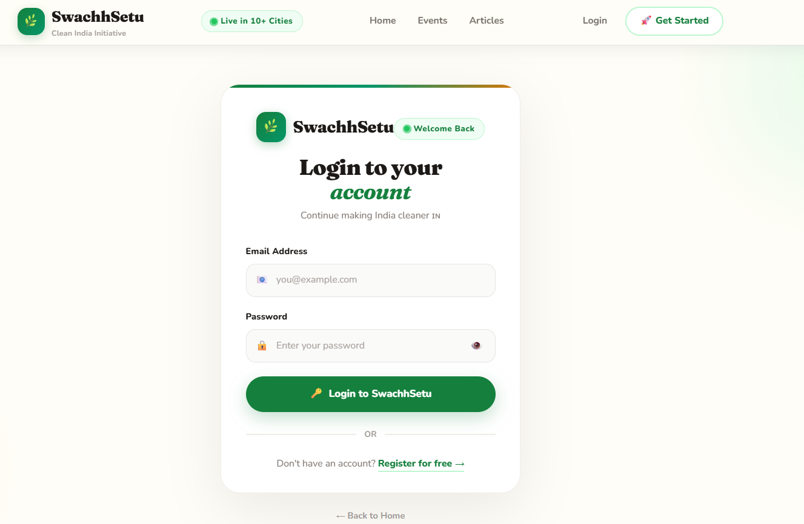

1.3 Login

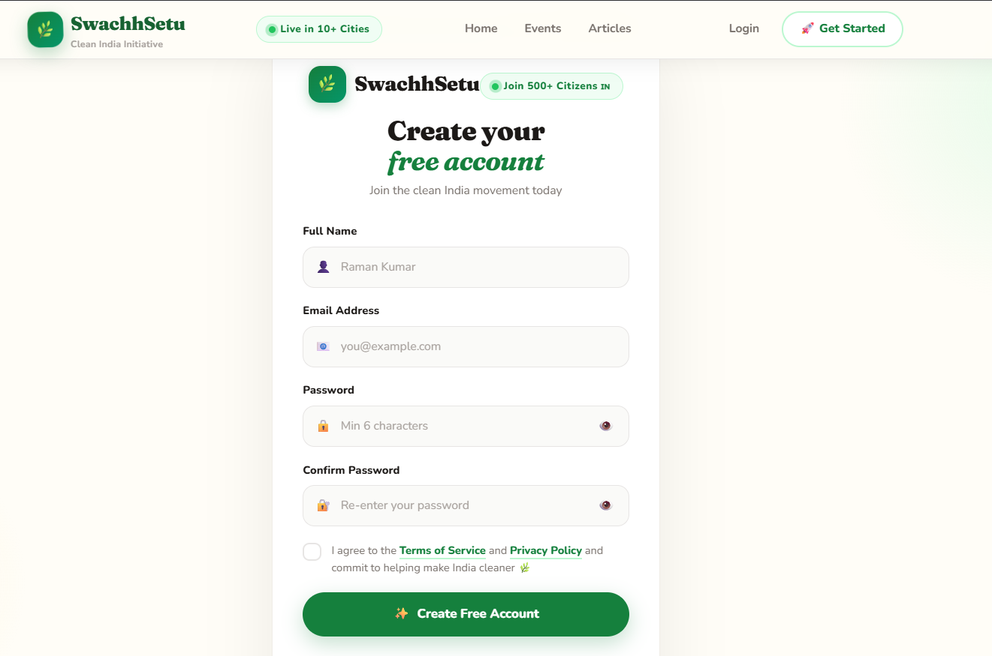

1.4 Register

-Different Sections

Events
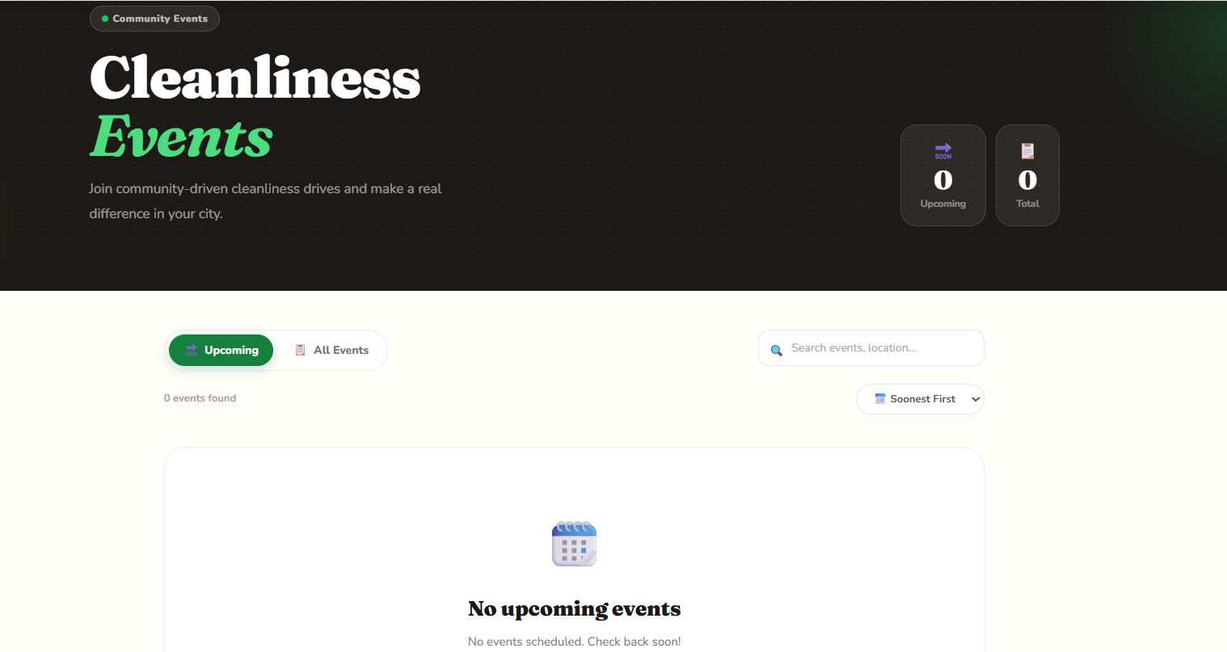

1.5 Events

Articles
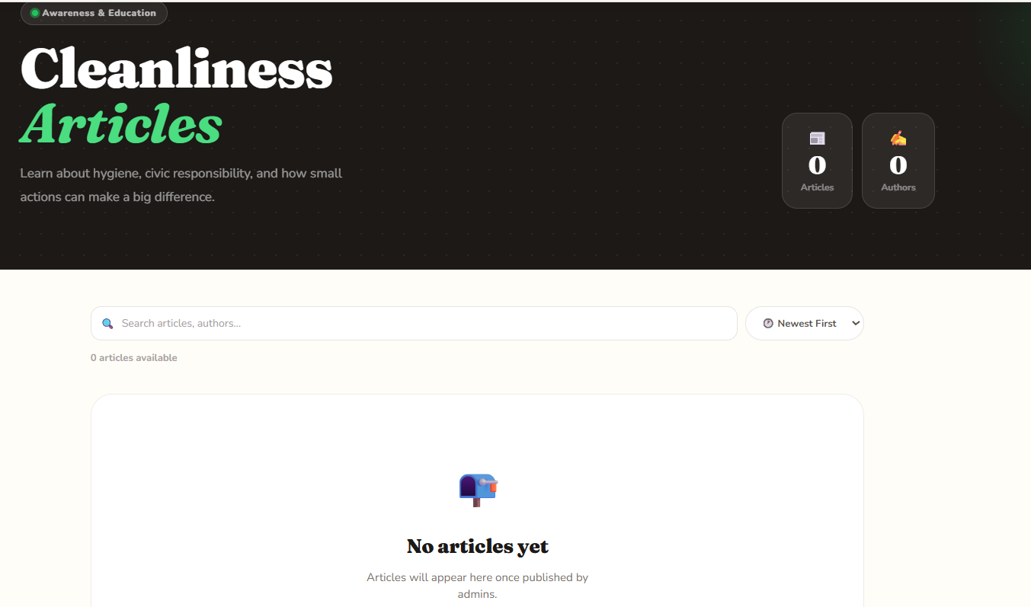

1.6 Articles

Admin

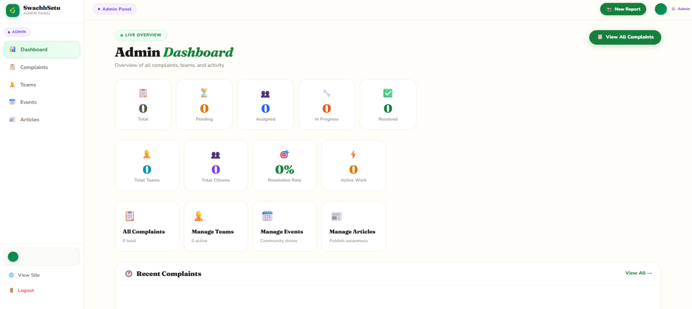

Profile
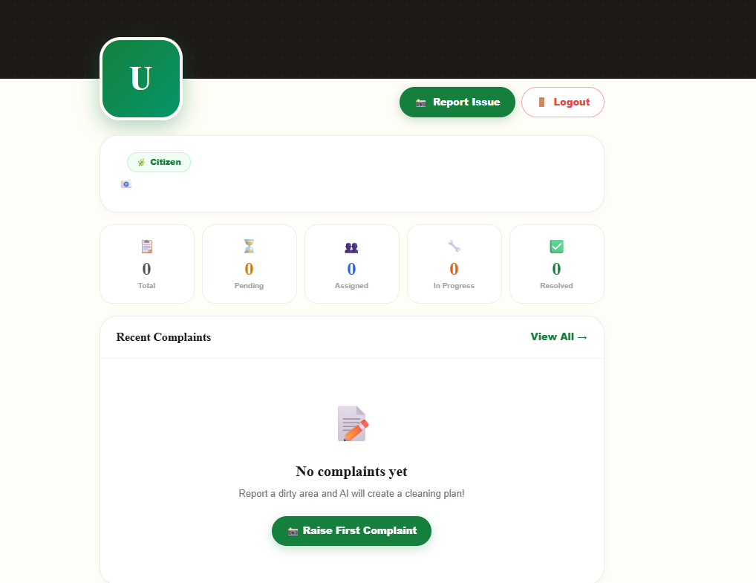

Interface of the backend & files structure of spring boot.

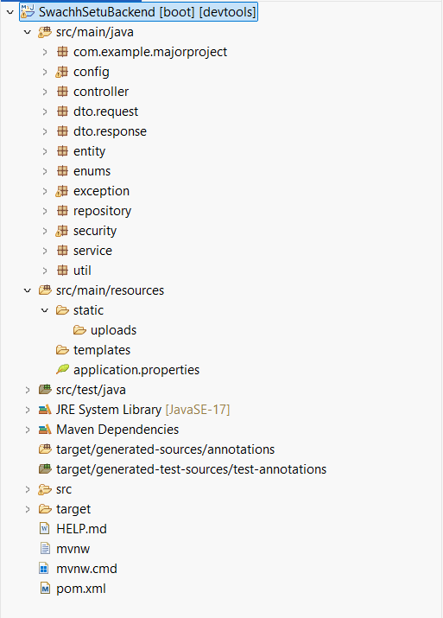

Application.properties:

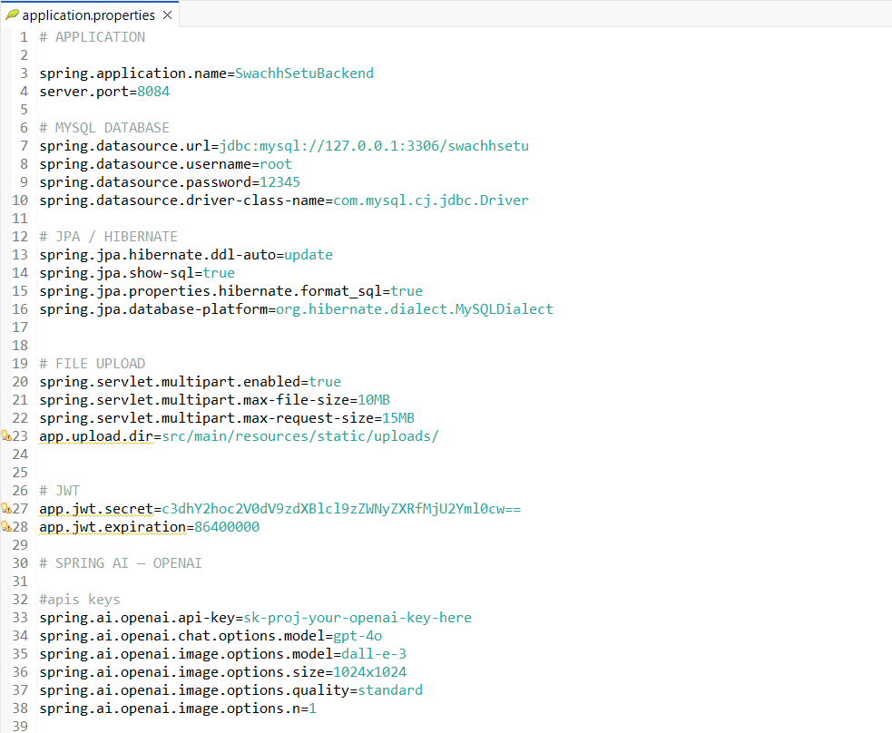

CONCLUSION
SwachhSetu is developed with a clear vision - to make civic cleanliness reporting simple, intelligent, and actionable for every citizen. Through this project, we have successfully designed and implemented a full-stack AI-powered platform that connects citizens directly with municipal authorities in a transparent and efficient manner.
The platform addresses a genuine real-world problem that affects millions of people across Indian cities and towns every day. By combining modern web technologies like ReactJS and Tailwind CSS on the frontend with a robust Java Spring Boot backend and Spring AI integration, SwachhSetu goes beyond being just a complaint portal - it actively responds to complaints using artificial intelligence by generating step-by-step cleaning instructions and a visual representation of how the reported area would look after cleaning.
The three-tier user model - Citizens, Administrators, and Cleaning Teams - ensures that every stakeholder in the cleanliness ecosystem has a dedicated and purposeful role within the platform. The admin panel brings accountability and structure to municipal operations, while the AI response layer brings immediate value to the citizen experience.
From a technical standpoint, this project provided hands-on experience with several industry-relevant technologies - REST API development with Spring Boot, AI integration using Spring AI, relational database design with MySQL, component-based UI development with ReactJS, and secure authentication using Spring Security and JWT. Each of these technologies was applied in a real problem context, making the learning deeply practical and meaningful.
SwachhSetu, in its current form, lays a strong foundation for a scalable civic technology solution. With further development, it has the potential to be deployed across municipalities of varying sizes and contribute meaningfully to initiatives like Swachh Bharat Abhiyan. The project demonstrates that technology, when applied thoughtfully to civic challenges, can drive real and lasting change in the quality of urban life.
.

REFERENCES

- ReactJS — Official Documentation https://react.dev/

- Tailwind CSS — Official Documentation https://tailwindcss.com/docs/

- Java Spring Boot — Official Documentation https://spring.io/projects/spring-boot

- Spring AI — Official Reference Guide https://docs.spring.io/spring-ai/reference/

- Spring Security — Official Documentation https://spring.io/projects/spring-security

- MySQL — Official Documentation https://dev.mysql.com/doc/

- OpenAI API — Official Documentation (used via Spring AI) https://platform.openai.com/docs/

- JSON Web Token (JWT) — Official Introduction https://jwt.io/introduction/

- Axios — Official Documentation https://axios-http.com/docs/intro

- Postman — Official Documentation https://learning.postman.com/docs/

- Git — Official Documentation https://git-scm.com/doc

- GitHub — Official Documentation https://docs.github.com/

